MUSIC FROM YOUTUBE AUDIO LIBRARY

https://www.youtube.com/audiolibrary/soundeffects?ar=2

Alone with My thoughts
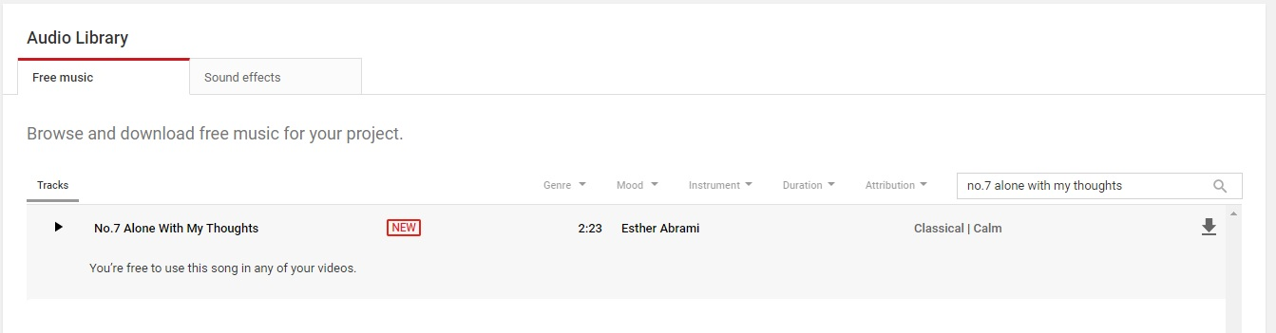

Treat Me This Way
